Password / Hash Cracking
Ethan Perdieu
CIT-40400
Directions: This lab will explore creating hashes and cracking them, followed by creating and cracking Linux and Windows user accounts. Answer the questions and upload screenshots in one PDF.
Note: JTR is good for CPU-based cracking, but Hashcat is better at GPU-based cracking. It depends on your computer for performance. The commands below are not for hashcat but you can switch out the tool if needed.
- Change to root user or run an elevated command

- john –list=formats
  - shows the types of hash it can try to crack
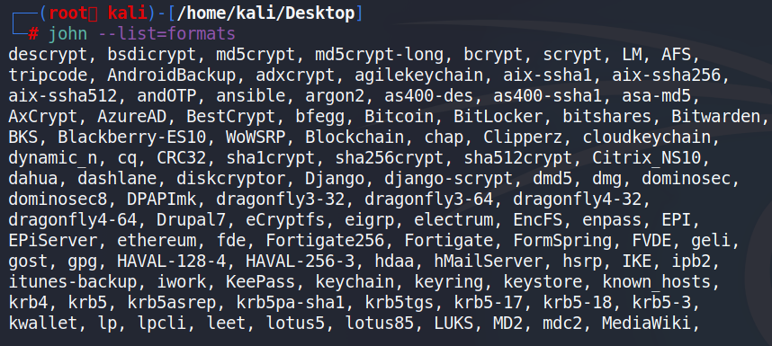

- Create 5-10 MD5 hashes and save them to a text file
  - Try to keep them under 8 characters, or they may take a long time.
  - Make sure to remember the name of the file and where it is located. I recommend using your desktop.
Echo -n hello | md5sum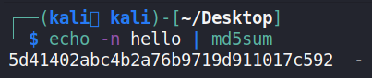

Created MD5 Hashes:
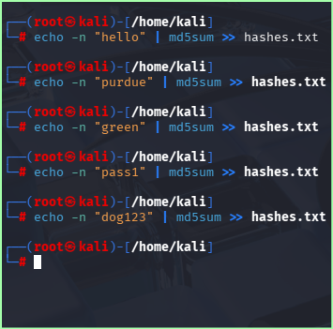

- Run JTR on the hash file
  - john filename.txt --format=RAW-MD5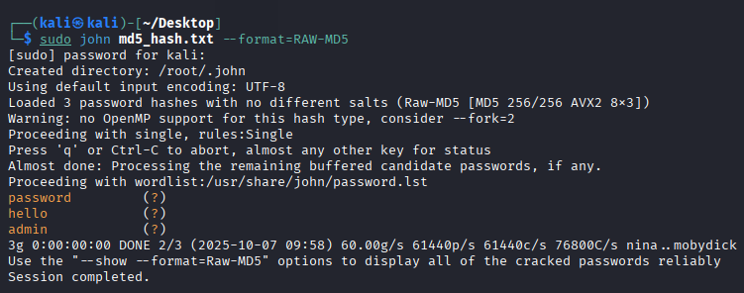

    - Notice how some of them are solved, but there isn’t a username next to it (?)
  - Screenshot your results
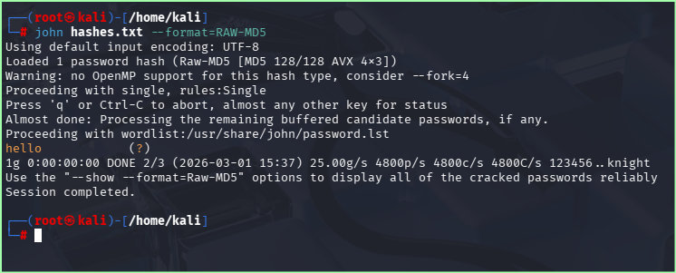
Create and Crack Linux User Accounts
- Create a dictionary .txt file on your desktop or a local you prefer
    - This should be a list of potential passwords. If you are picking a theme or category, feel free to choose (animals, places, colors, names, etc).
      - Your theme here may help you to customize your cracking command to specific characters (upper, low, #...etc) or min/max length
    - The intent here is not to have overly complex passwords

- Create 5+ different users and passwords
  - Make sure to use words from your dictionary file you just created, or they will likely not fall during class
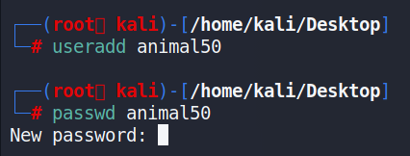
    - Command to del a username if needed
      - Sudo userdel username

- Navigate to /etc and find the shadow and passwd files
  - View the in information
    - Option #1 – views all information
      - cd /etc
      - Sudo cat shadow
    - Option #2 – combines and grep searches for username
      - Sudo cat /etc/shadow | grep -i username

- Copy the shadow and passwd file
  - Each file can be copied but a more effective approach is combining passwd & shadow files
    - sudo unshadow /etc/passwd /etc/shadow > outputfile.txt
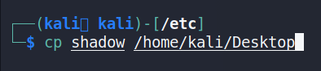

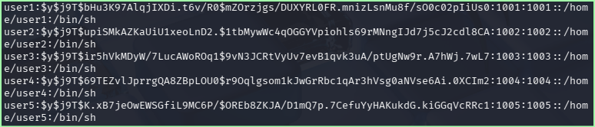
  - To view the file use the “Cat” or concatenate command
    - Looking at the file can help to determine the type of hash. Kali NTH, hash identifier and CyberChef can help identify a hash.
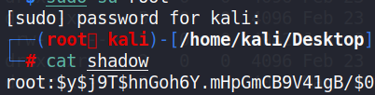
Syntax username: $hash number$salt$hashed password:
Symbol | Hash Algorithm
$1$ | MD5
$2$ | Blowfish
$5$ | SHA-256
$6$ | SHA-512
$7$ or $y$ | yescrypt

- Run JTR to start the cracking process
  - You may need to change the .txt file name to match your file you created and location.
  - Your dictionary attack should be very quick if you put the passwords in it.
  - After having success with the dictionary try doing incremental and other variations to see how much more challenging it is.
  - Try at least 3 variations including dictionary (min/max length, character set, usernames…etc). https://www.openwall.com/john/doc/MODES.shtml
    - John shadow –format=crypt --wordlist=dictionary.txt
    - John shadow-format=crypt –users=admin1, admin2, admin3
      - Replace the names for users if you know them. This saves time since JTR does not have to solve the users names.
  - Screenshot your results
Dictionary Attack:
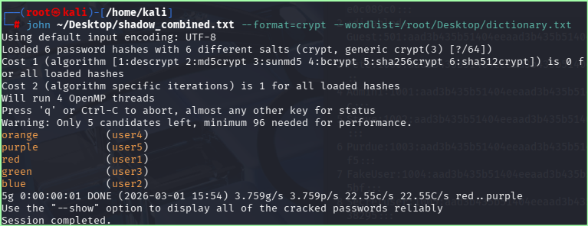

Targeting Specific Users:
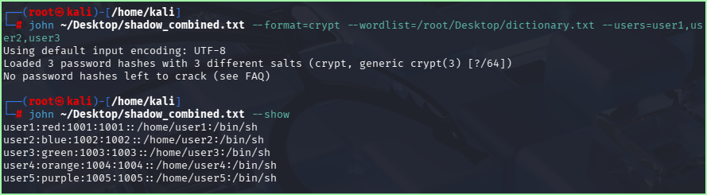

Incremental Bruce Force:
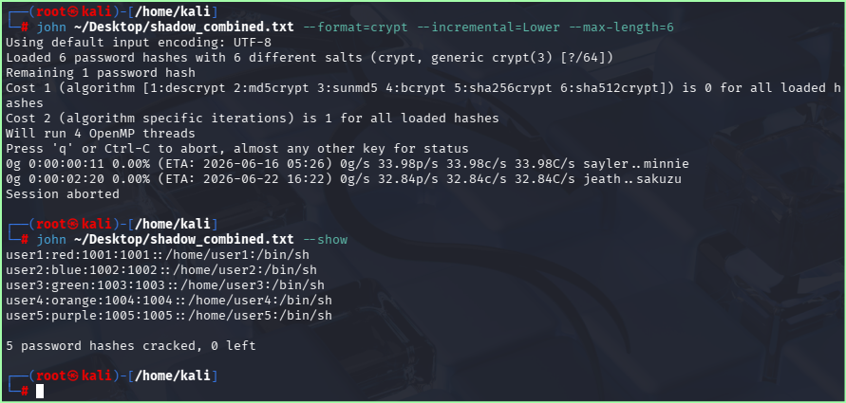
Shows the brute force attack ETA would be June 2026.

- View cracked passwords
    - john filename --show

- List 3 things and explain how they help to mitigate or defend against password attacks?
One thing some can implement to help defend against password attacks is MFA. So even if the password is cracked, the attacker would still need to acquire the second form of verification. This could be through a code texted to a phone number or an authenticator app.

Another tool they can use to help mitigate against a password attack is a password manager. This will allow them to generate and store unique passwords for every account they own. This helps against password reusing and ensures that brute force is useless against them.

The third tool they can use to defend against password attacks is some sort of lockout system. This prevents password attempts after a certain number of failed logins occur. This once again prevents brute force and incremental attacks like JTR does.

Another Way to Create Passwords to Practice Cracking
- Create a password without creating a new user. Mkpasswd creates a random password. Adding a number after mkpasswd sets the character length.
  - mkpasswd -m sha-512 -S saltcode -s studentname
  - The hash type can be changed as well (md5, sha-256 ..etc)
  - Insert screenshot

- Identify the hash type with name-that-hash or hashid
  - I do not recommend using an online identifier because you are giving them information
  - We created the random password and already know it is MD5 but use hash-identifier

- Create a couple using MD5 and then try to crack them with JTR
  - Shows hashes available
    - mkpassd -m help
    - Insert screenshot
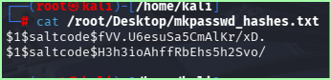
Used hello and dog ^
  - Remember to copy and paste outputs into a text file
  - If you start an incremental:ASCII, you can hit space bar to see progress
  - It make be very difficult to crack, so don’t waste too much time. No worries if you are not able to crack them.
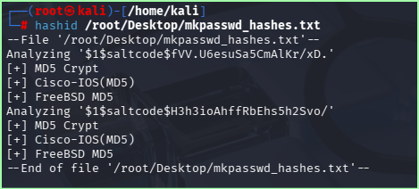

View wordlists available for dictionary attacks
- Navigate to /usr/share/wordlists
  - Run ls command
- rockyou.txt is the default wordlist for JTR
  - The 2024 version has 10 billion words and is over 145GB
- To use a specific wordlist command
  - John [file being cracked] –wordlist=/location_of_dictionary_file
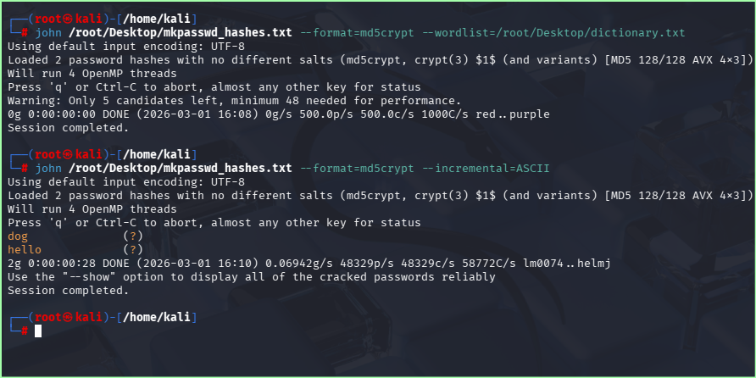

Windows (SAM) Cracking
References: https://hashcat.net/wiki/doku.php?id=hashcat
- Samdump2 works on Win7 but not on newer versions. Mimikatz or other tools are better suited for this.

- Use JTR or hashcat on the provided Windows 7 credentials on Brightspace
  - JTR likes –format=LM or NT
  - Syntax of SAM/SYSTEM Username:UID:LMhash:NTLMhash:::

- Document what you commands and/or approaches you took to try and crack these
I First used the copy command to get the win7_hashes text file into my downloads folder.

Cp /home/kali/Downloads/win7_hashes.txt ~/Desktop/

Then I ran the dictionary attack using the rockyou library:
john ~/Desktop/win7_hashes.txt –format=NT –wordlist=/usr/share/wordlists/rockyou.txt
  - Reminder there are different attacks
  - Dictionary may or may not be the fastest
  - You can also create custom dictionaries
  - Try setting the character length and character sets to speed up the process
  - Provide screenshot of cracked passwords
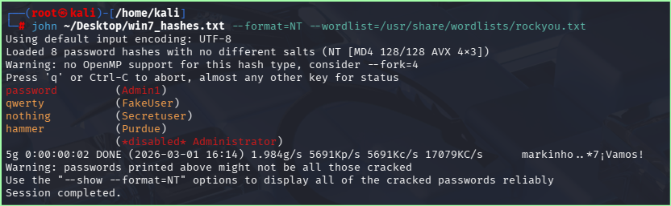
    - You may need to separate the NTLM hash from the other part of the file and then line it back up with the username

- Write a paragraph on issues you encountered and how you were able to correct them. If you were not able to crack anything, what do you think went wrong?

I did encounter a few issues during the lab such as when the rockyou.txt file was zipped. The command was not working unless I used a command to unzip that txt file. Another issue I had was locating the win7_hashes.txt after downloading it. I did not realize that it was not in my Desktop folder and instead was still in downloads. This is why I ended up running the copy command.

